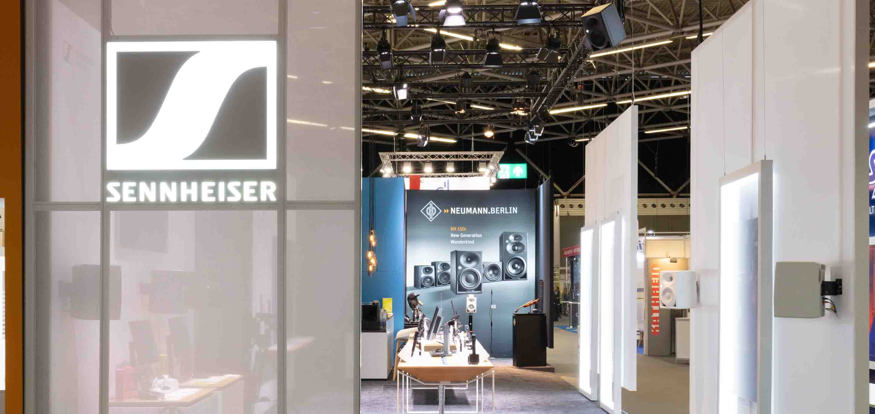

The Sennheiser Group at IBC 2023
New immersive innovations, content creation and broadcast audio solutions, plus an invite-only preview of the future of wireless audio – meet the group’s latest remarkable advancements

Wedemark, 15 August 2023 – Audio at its best: at IBC, Sennheiser, Neumann, Dear Reality and Merging Technologies will demonstrate state-of-the art immersive production workflows as well as exciting solutions for audio capture, monitoring and processing. Creators and audio professionals of all levels are welcomed to stand D50 in Hall 8.

Four spaces invite IBC visitors to explore state-of-the-art solutions for today’s content production: (1) the immersive presentation zone, (2) active and passive product islands, (3) a Neumann area and (4) a separate Wireless Multichannel Audio Systems (WMAS) zone.

- The immersive zone
In the immersive presentation zone, which is powered by a 5.1.4 Neumann monitor set-up with nine KH 150 monitor loudspeakers and two KH 750 DSP subwoofers, guests will be able to get hands-on with the Dolby Atmos/immersive broadcast workflows facilitated by the products of Merging Technologies, the latest member to join the Sennheiser Group. The company shows their Anubis, Hapi, Pyramix and Ovation solutions integrated in typical broadcast workflows. In addition to their new Dolby Atmos certified monitoring package, Merging Technologies will show a brand-new interpretation solution.

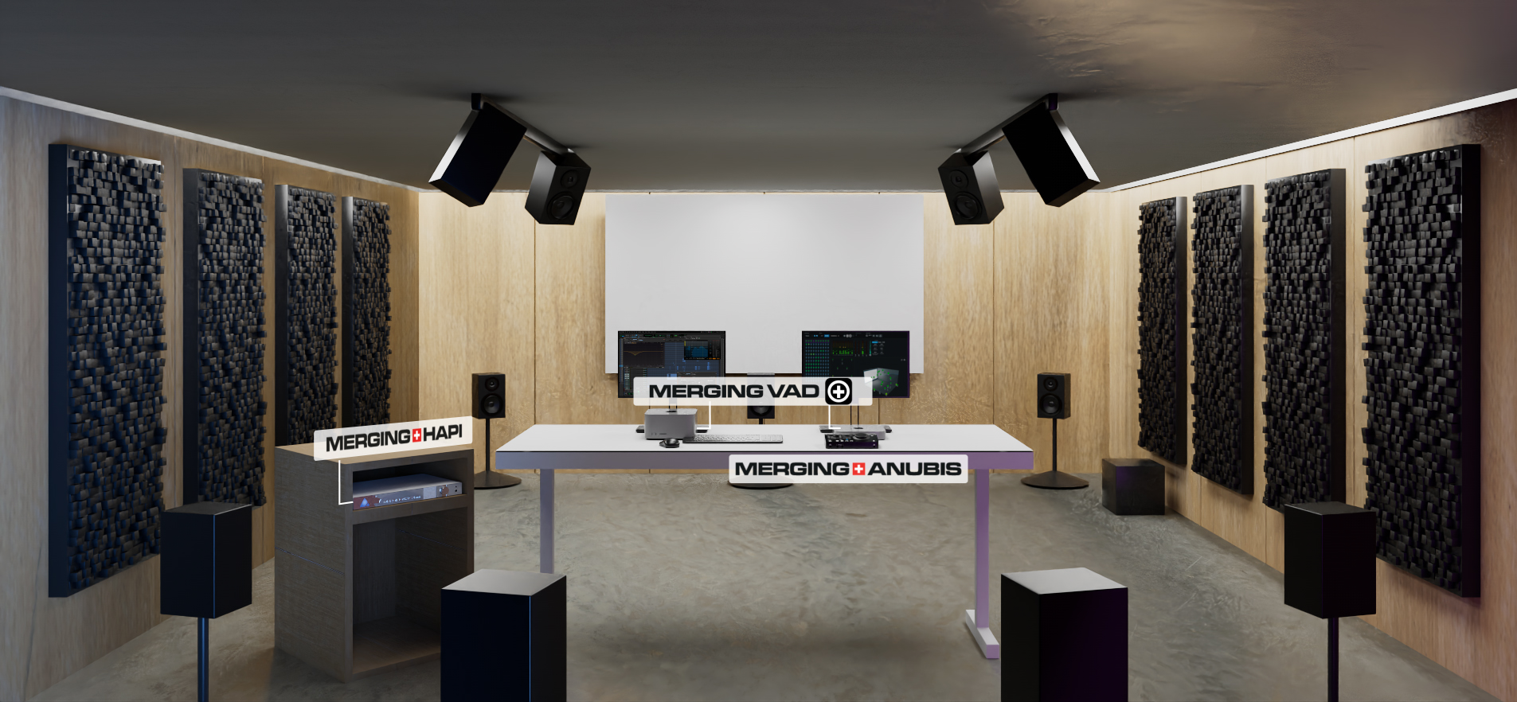 | The Atmos bundle from Merging Technologies includes the Anubis Pro, Hapi MK II, VAD and SoundID – a no-compromise 9.1.6 immersive audio package

In the same space, visitors are invited to experience Dear Reality’s dearVR SPATIAL CONNECT for Wwise. The software is previewed at IBC for the first time – and enables game designers to develop the audio directly in the VR or AR gaming environment, instead of having to switch between systems. The in-game mixing workflow will provide a revolutionary in-headset control of Wwise audio middleware sessions and will improve the workflow for next-generation XR productions.

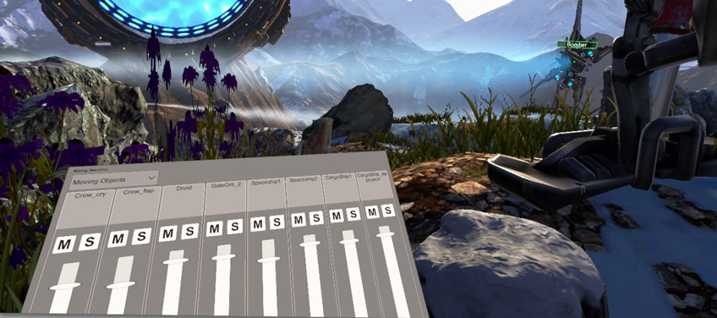 | A preview of Dear Reality’s dearVR SPATIAL CONNECT for Wwise: Game audio designers will have direct in-headset access to the Wwise mixers, including the ability to solo and mute

Other presentations in this area include AMBEO 2-Channel Spatial Audio for live production, using an Anubis to create an enhanced immersive stereo feed from an immersive audio production source, and information sessions on WMAS, Sennheiser’s broadband wireless technology.

- Audio in focus: product islands
Product islands across the stand highlight various aspects of the audio production workflow, such as location-independent monitoring of multichannel formats, which is facilitated through Dear Reality’s dearVR PRO spatializer and dearVR MONITOR with any set of good monitoring headphones.

Sennheiser wireless audio solutions centre around the Evolution Wireless Digital family and its Smart Asist app and WSM software. A special focus is on the new EW-DP series for broadcasters (ENG), videographers and filmmakers, and the series’ plug-on transmitter with recording functionality that will be available at the end of October. For ENG work, Sennheiser’s 1.9 GHz solution AVX will be on display, too, while EW-DX and Digital 6000 wireless microphone systems cater to live audio productions and broadcast studio applications.

Whether recording music in the studio, shooting an interview for an ENG job or recording the sounds of earth’s most remote places, the Sennheiser MKH 8000 RF condenser microphone series has become a firm favourite with sound engineers, broadcasters and field recordists. Sennheiser will showcase the new MZF 8000 II broadcast filter, and also preview another addition to the series.

Part of the creators’ offer, the Sennheiser Mobile Kits (e.g. the MKE 400 mini shotgun microphone) are a great choice for content creation with DSLRs and mobile phones, while the Profile USB microphone provides an ideal entry into podcasting. Professional broadcast headsets for cameramen and commentators, as well as monitoring headphones for the studio and ENG work, round off the product offer.

The product island for content creators will include the Profile Streaming Set | 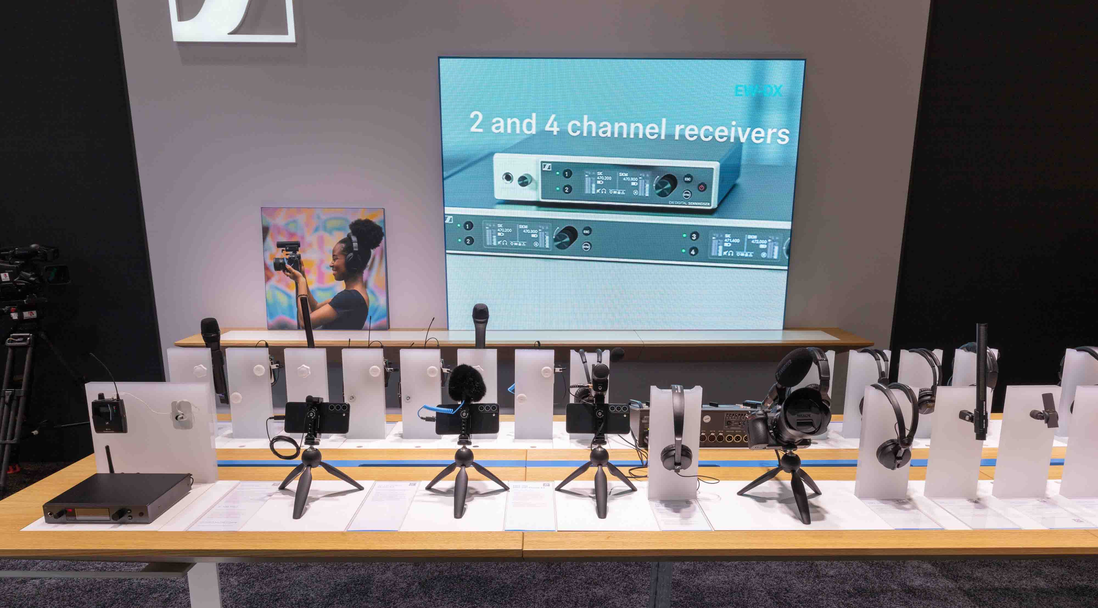

(3) The Neumann.Berlin area
On active display are the company’s new MT 48 audio interface and a wide variety of its classical studio microphones, including the BCM 104 and BCM 705 broadcast microphones, the M 49 V, the TLM 102, the revered U 87 Ai and the KU 100 binaural head. Visitors can also try out the Neumann NDH 20 and NDH 30 with music from their own smartphones – including the brand-new black version of the NDH 30 that will start shipping from September.

The Neumann MT 48 audio interface | 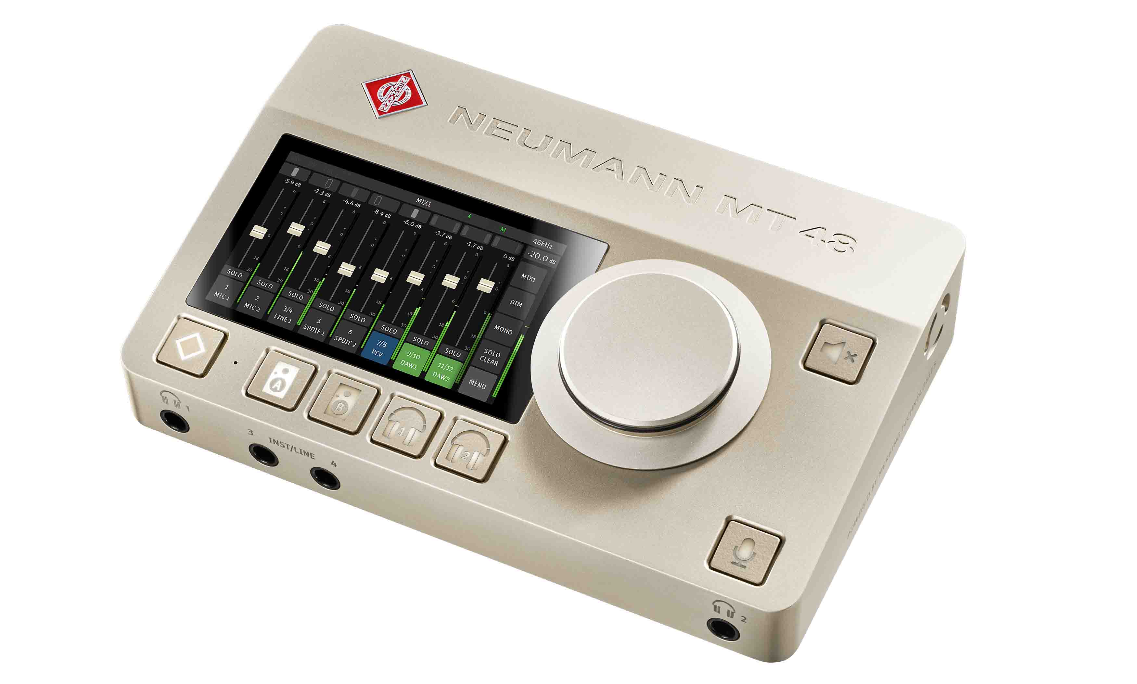

For live audio applications, Neumann’s KM small-diaphragm mics and the MCM Miniature Clip Mic System are on display, including the many dedicated mounting accessories that make MCM such a great choice for close-miking instruments.

(4) WMAS: Experience the future of wireless transmission today
In a separate, closed-to-the-public experience space just across the aisle (8C47), VIP customers will get demonstrations and first-hand information on WMAS, the game-changing broadband wireless technology currently developed by Sennheiser. At the main stand, presentations of the technology will be given on the Friday afternoon and Saturday of the show.

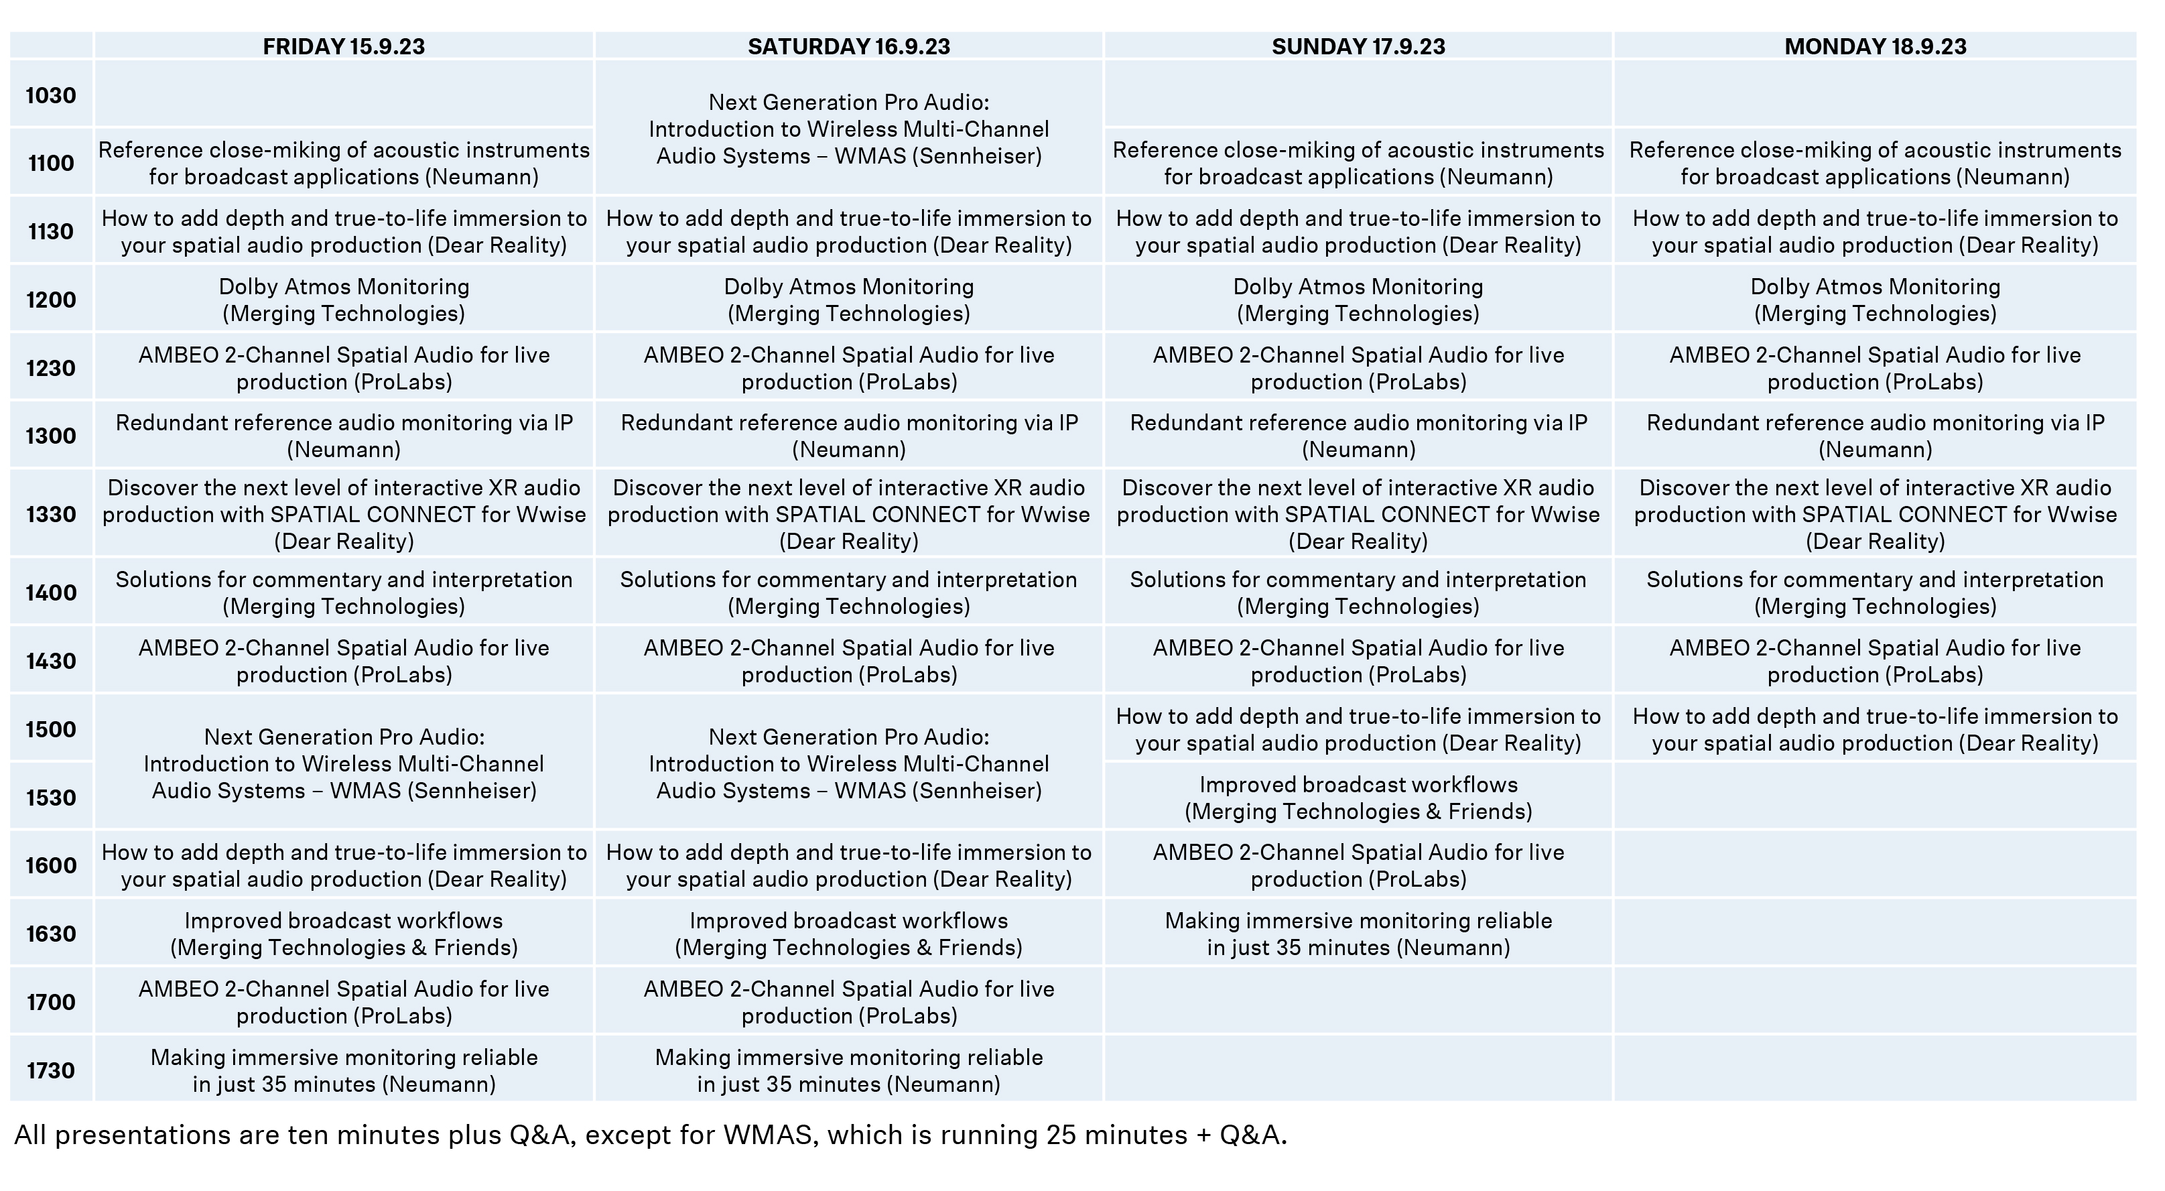 Presentation schedule

Visit the Sennheiser Group at IBC, RAI Amsterdam, 15 to 18 September, Hall 8, Stand D50.

(Ends)

The images accompanying this media release can be downloaded here.

About the Sennheiser Group

Building the future of audio and creating unique sound experiences for our customers - this is the aspiration that unites the employees of the Sennheiser Group worldwide. The independent family-owned company Sennheiser was founded in 1945. Today, it is managed in the third generation by Dr. Andreas Sennheiser and Daniel Sennheiser, and is one of the leading manufacturers in the field of professional audio technology.
sennheiser.com | neumann.com | dear-reality.com | merging.com

